Ex. No:5 | Jenkins deployment Using Docker
11-09-2025

Aim
To learn how to deploy Jenkins inside Docker and use a Jenkins pipeline to generate, publish, and archive a simple static website.

Description
Jenkins is an open-source automation server used to automate tasks related to building, testing, and deploying software. It helps implement Continuous Integration (CI) and Continuous Deployment (CD) pipelines.
In this lab, Jenkins is run inside a Docker container using Docker Compose. A pipeline is defined in a Jenkinsfile which consists of stages:

Generate Site: Creates a simple static HTML and CSS website.

Publish Site: Uses the HTML Publisher plugin to render the site inside Jenkins.

Archive Artifacts: Stores the generated site files for download or further use.

Components used in the process of Running Jenkins:

Jenkins: Automation server for CI/CD pipelines.

Docker: Platform to run applications in lightweight, portable containers.

Docker Compose: Tool to define and run multi-container Docker applications.

Jenkinsfile: Text file containing pipeline definition in Declarative or Scripted syntax.

Pipeline: Automated workflow in Jenkins, divided into stages and steps.

HTML Publisher Plugin: Jenkins plugin to display HTML reports inside Jenkins.

Artifact: Files produced by a build, which can be archived for future reference.

Jenkins allows automating software tasks via pipelines. Key concepts include:

Job/Project: Defines the steps to build or deploy software.

Build: A single execution of a job.

Node/Agent: A machine where the pipeline runs (can be local or remote).

Common Commands:

docker exec <container_name> <command> → Run a command inside a Docker container.

docker ps → List running containers.

docker logs <container_name> → View logs of a container.

docker compose up -d → Start containers defined in docker-compose.yml in detached mode.

docker compose down → Stop and remove containers.

sh 'command' → Execute shell commands inside Jenkins pipeline.

Prerequisites

Before starting the lab, you need:

- A laptop or VM with Docker and Docker Compose installed.

- Internet access to pull Docker images.

- Jenkins running inside Docker (jenkins/jenkins:lts).

- Basic knowledge of Git and command-line operations.

Procedure

STEP 1 — Create a new project folder

Create a folder for the lab:

mkdir ~/jenkins-static-site && cd ~/jenkins-static-site

Create a docker-compose.yml file:

version: '3.8'

services:

jenkins:

image: jenkins/jenkins:lts

container_name: jenkins

restart: unless-stopped

ports:

- "8080:8080"

- "50000:50000"

volumes:

- jenkins_home:/var/jenkins_home

- /var/run/docker.sock:/var/run/docker.sock

volumes:

jenkins_home:

driver: local

Start Jenkins:

docker compose up -d

Get the initial admin password:

docker exec jenkins cat /var/jenkins_home/secrets/initialAdminPassword

Open Jenkins in the browser: http://localhost:8080

Complete setup → install suggested plugins → create admin user.

STEP 2 — Install HTML Publisher Plugin

In Jenkins: Manage Jenkins → Plugins → Available Plugins.

Search for HTML Publisher and install it.

Restart Jenkins if prompted.

STEP 3 — Create the Pipeline Job

In Jenkins, click New Item → select Pipeline → name it karunya-site-pipeline .

Scroll to Pipeline → Definition and select Pipeline script.

Paste the following script:

pipeline {

agent any

stages {

stage('Generate site') {

steps {

script {

sh 'rm -rf site || true'

sh 'mkdir -p site/assets'

writeFile file: 'site/index.html', text: """

<!doctype html>

<html lang="en">

<head>

<meta charset="utf-8"/>

<meta name="viewport" content="width=device-width, initial-scale=1"/>

<title>Karunya University — Simple Site</title>

<link rel="stylesheet" href="assets/style.css"/>

</head>

<body>

<header class="site-header">

<div class="container">

<h1>Karunya University</h1>

<p class="tagline">Values — Knowledge — Service</p>

</div>

</header>

<main class="container">

<section class="card">

<h2>About Karunya University</h2>

<p>Karunya Institute of Technology and Sciences is a leading centre for higher education in India.</p>

</section>

</main>

<footer class="site-footer container">

<p>&copy; ${new Date().format('yyyy')} Karunya University — Generated by Jenkins</p>

</footer>

</body>

</html>

"""

writeFile file: 'site/assets/style.css', text: """

body {

font-family: Arial, sans-serif;

margin: 0;

}

.container {

max-width: 800px;

margin: 0 auto;

padding: 20px;

}

.site-header {

background: #0b3d91;

color: #fff;

padding: 20px;

}

.tagline {

font-size: 14px;

opacity: 0.8;

}

.card {

background: #fff;

border: 1px solid #ddd;

padding: 15px;

margin: 15px 0;

border-radius: 6px;

}

.site-footer {

text-align: center;

font-size: 12px;

color: #555;

margin-top: 20px;

}

"""

}

}

}

stage('Publish site') {

steps {

publishHTML([

allowMissing: false,

alwaysLinkToLastBuild: true,

keepAll: true,

reportDir: 'site',

reportFiles: 'index.html',

reportName: 'Karunya University - Simple Site'

])

}

}

}

post {

always {

archiveArtifacts artifacts: 'site/**', fingerprint: true

}

}

}

Save the pipeline

STEP 4 — Run and View the Website

--------------------------------

Click Build Now.

After success, go to the build page.

On the left menu, click Karunya University - Simple Site.

You should see the static site rendered inside Jenkins.

Alternatively, download the archived artifact (the site/ folder) and open index.html locally.

Output
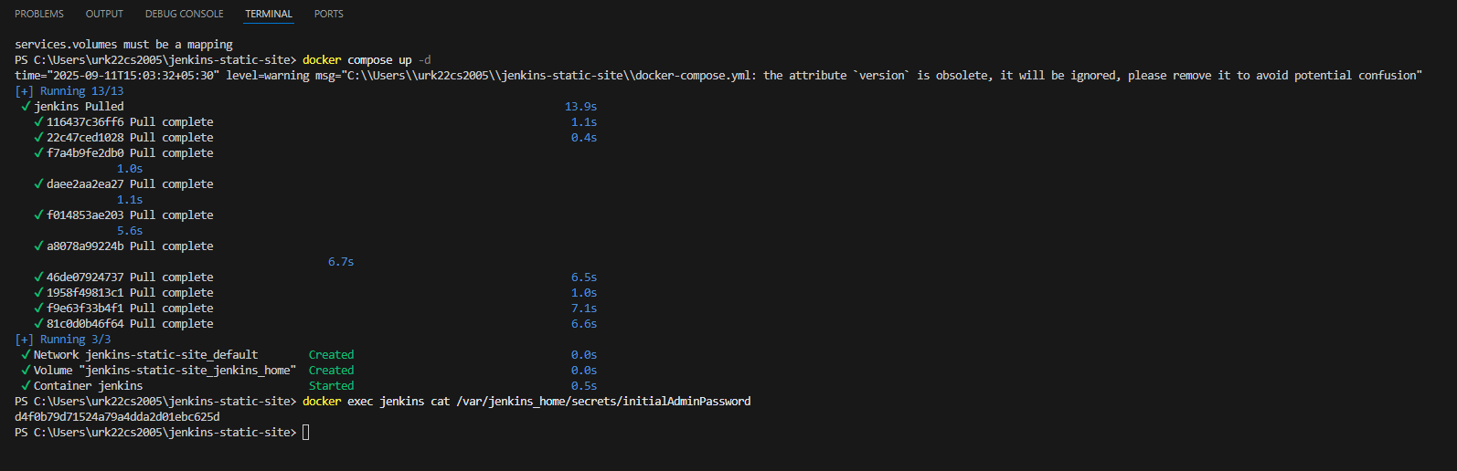

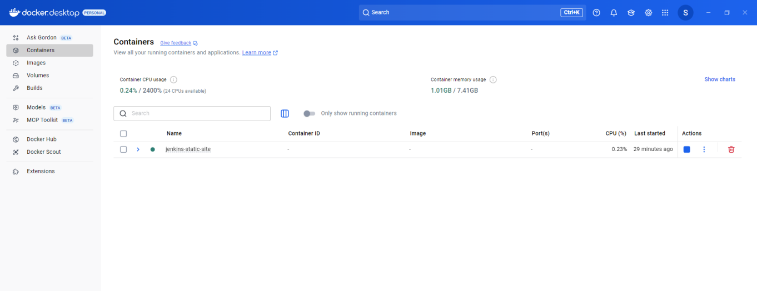



Result
Jenkins deployed using Docker generated, published, and archived a simple static website successfully.

